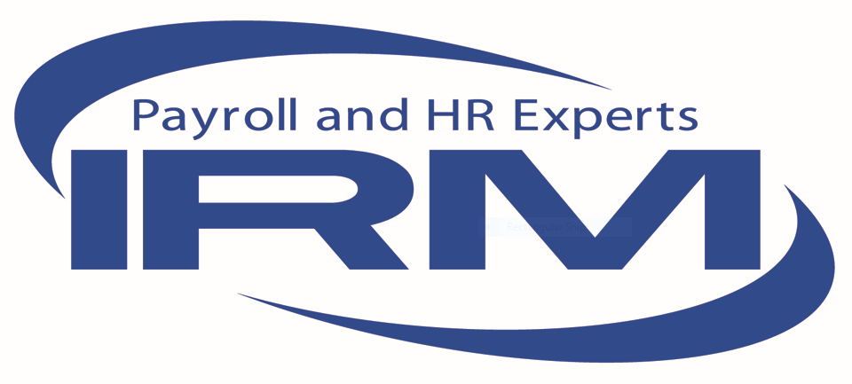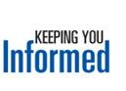

**What You Should Know About the ADA, the Rehabilitation Act and the Coronavirus**

* The EEOC enforces workplace anti-discrimination laws including the Americans with Disabilities Act (ADA) and the Rehabilitation Act, including the requirement for reasonable accommodation and rules about medical examinations and inquiries.
* The ADA and Rehabilitation Act rules continue to apply, but they do not interfere with or prevent employers from following the [guidelines and suggestions made by the CDC](https://www.cdc.gov/coronavirus/2019-ncov/specific-groups/guidance-business-response.html) about steps employers should take regarding the Coronavirus.
* The EEOC has provided [guidance](https://www.eeoc.gov/node/17787), consistent with these workplace protections and rules, that can help employers implement strategies to navigate the impact of Coronavirus in the workplace.
* The EEOC guidance identifies relevant established ADA and Rehabilitation Act principles and answers questions frequently asked about the workplace during Coronavirus-like events such as:
  + How much information may an employer request from an employee who calls in sick, in order to protect the rest of its workforce during a Coronavirus-like event?
  + When may an ADA-covered employer take the body temperature of employees during a Coronavirus-like event?
  + Does the ADA allow employers to require employees to stay home if they have symptoms of the Coronavirus?
  + When employees return to work, does the ADA allow employers to require doctors' notes certifying their fitness for duty?